Willmott Dixon Holdings Ltd.

PAS 2060: 2014 specification for the demonstration of carbon neutrality

Qualifying explanatory statement in support of PAS 2060:2014 self-certification

Achievment period: 1 Jan 21 – 31 Dec 21
Commitment period: 1 Jan 22 – 31 Dec 22

December 2022


Contents
Introduction 1
Declaration of Achievement of Carbon Neutrality 2
Declaration of Commitment to Carbon Neutrality 3
Appendix A - Quantifying our Carbon Footprint 4
Appendix B – Carbon Footprint Management Plan 7
Appendix C – Carbon Offsetting 11
Appendix D – Scope 3 Emissions 12

Introduction
This document forms the PAS 2060 Qualifying Explanatory Statement to demonstrate that Willmott Dixon Holdings Ltd has achieved carbon neutrality in accordance with PAS 2060:2014 at 31 December 2021 with commitment to maintain to 31 December 2022 for the period commencing 1 January 2022, self-declared.
PAS 2060 Requirement | Response
Entity making declaration: | Willmott Dixon Holdings Ltd (WDH)
Subject of PAS 2060 declaration: | All offices, commercial premises and construction sites for which Willmott Dixon Holdings Ltd has financial control of energy consumption, as well as all leased vehicles, associated grey fleet (privately owned vehicles used for business and commuting mileage) and train travel (business and commute mileage).
Description of subject: | Willmott Dixon Holdings Ltd is a privately-owned contracting and interior fit-out group.
Rationale for selection of the subject: | The scope and subject of this PAS 2060 statement includes all emissions based on the operational control principle defined in the WRI GHG Protocol – Corporate standard.
Type of conformity assessment: | Self-certification
Baseline date for PAS 2060 programme: | 1st Jan 2021 – 31st Dec 2021
Historic reduction period | 1st Jan 2020 – 31st Dec 2020
Achievement Period: | 1st Jan 2021 – 31st Dec 2021
Commitment Period: | 1st Jan 2022 – 31st Dec 2022
This Qualifying Explanatory Statement contains information pertaining to the subject’s carbon neutrality. Any and all information herein is believed to be correct at the time of issue.

Declaration of Achievement of Carbon Neutrality

PAS 2060 Requirement | Willmott Dixon Response
Period during which the entity is demonstrating carbon neutrality of the subject has been achieved. | 1st January 2021 – 31st December 2021
Recorded carbon footprint of the subject during the period stated above. | Application period:  5,716 tCO₂e
Which PAS 2060 recognized methodology has been followed to achieve carbon neutrality? | WBCSD/WRI Greenhouse Gas Protocol, Corporate Accounting and Reporting standard (revised edition, March 2004).
How have the reductions in GHG emissions during the period been achieved? | Internal reduction and offsetting
Location of information supporting claims. | Appendix A
Location of the details describing internal reductions achieved. | Appendix A & B
Location of the details describing the carbon offsets. | Appendix C
UK economic growth rate over the application period | 2021: 7.4%
Name of Senior Representative | Signature
Rick Willmott  Group Chief Executive with responsibility for sustainable development | 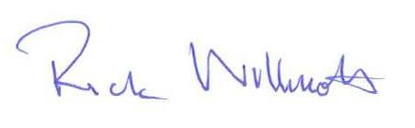
Date: December 2022

Declaration of Commitment to Carbon Neutrality

PAS 2060 Requirement | Willmott Dixon Response
Period during which the entity commits to maintaining carbon neutrality of the subject. | 1st Jan 2022 - 31st Dec 2022
Which method, as recognized by PAS 2060, will be followed to achieve carbon neutrality? | WBCSD/WRI Greenhouse Gas Protocol, Corporate Accounting and Reporting standard (revised edition, March 2004).
Prior commitment to carbon neutrality made by entity. | Yes
Carbon footprint of the subject for the historic reductions period (immediately prior to the start of the commitment). | AP5 5,716 tCO2e
Location of GHG emissions report supporting this claim | Appendix A
Location of the Carbon Footprint Management Plan | Appendix B
Name of Senior Representative | Signature
Rick Willmott
Group Chief Executive with responsibility for sustainable development
Date: December 2022

Appendix A - Quantifying our Carbon Footprint

Summary

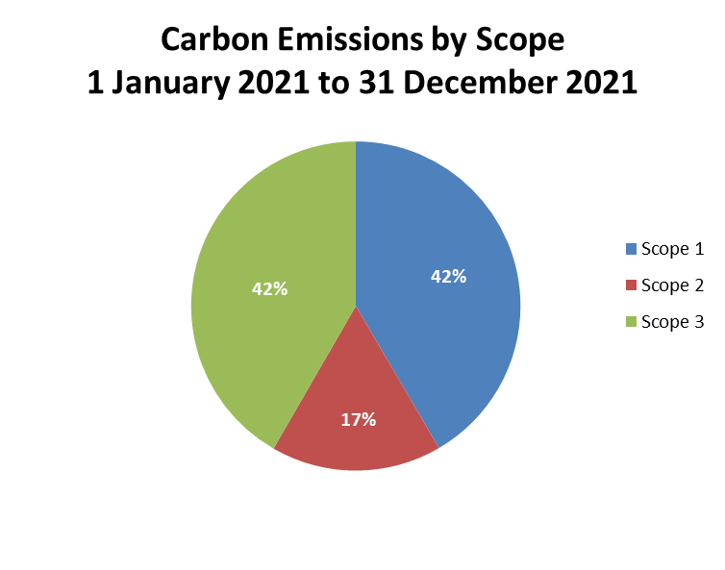

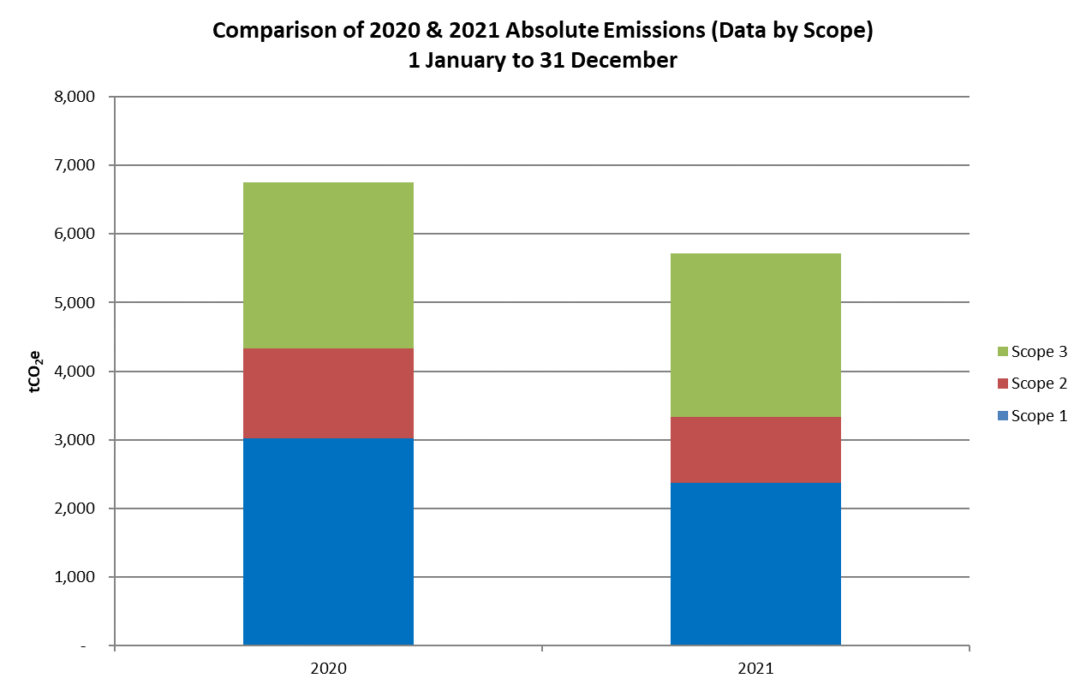

Emissions Scope | Description | 2021 Emissions (tCO₂e)
Scope 1 | Direct emissions from company cars, vans and fuel combustion (gas and site diesel) | 2,376
Scope 2 | Indirect emissions from consumption of electricity | 958
Scope 3 | Other indirect emissions from business travel (including business mileage by train), employee commuting, working from home equipment & heating estimations, carbon from waste and transmission & distribution losses (from scope 2 electricity consumption) | 2,382
Total Willmott Dixon Holdings Emissions |  | 5,716
Figure 1: Willmott Dixon Holdings Ltd Greenhouse Gas Emissions: 1st Jan 2021 – 31st Dec 2021
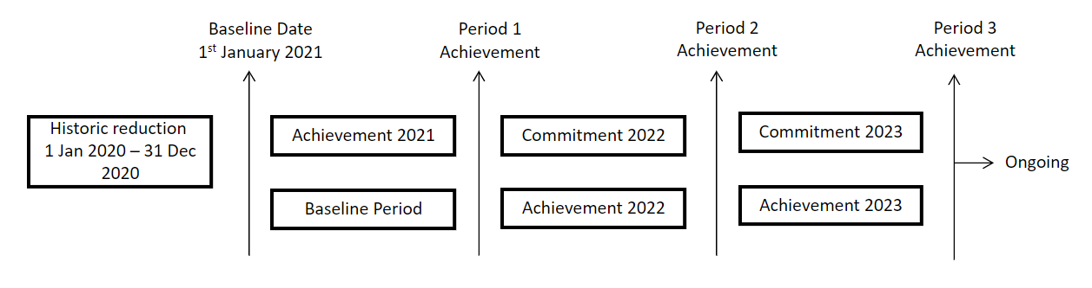
Figure 2: Willmott Dixon Holdings Ltd Carbon Neutral Declaration Periods
Methodology
Willmott Dixon categorises its GHG emissions as Scope 1, 2 and 3 as described in the WBCSD/WRI Greenhouse Gas Protocol Reporting standard (revised edition, March 2004). Emissions have been calculated as tonnes of carbon dioxide equivalent (tCO₂e) for Scope 1, 2 and selected Scope 3 sources (see Appendix D) using conversion factors listed in the Defra Greenhouse Gas Conversion Factors for Company Reporting for the relevant year. All Scope 2 emissions are now calculated using the market based methodology in line with our ‘Now or Never’ strategy and approved Science Based Target.
We calculate our carbon footprint using the principles of the GHG protocol and ISO14064 and our carbon footprint is then verified by The Carbon Trust as part of the Carbon Trust Standard.

Key Assumptions
Exclusions
The carbon footprint includes business travel from company vehicles, grey fleet and trains, as well as employee commuting by car and train. Other modes of business travel are excluded from the footprint but account for less than 1% of the footprint.

Car Mileage (excluding fuel cards)
Private car usage for commuting and business purposes as well as company car usage is recorded as mileage completed. GHG conversion factors specific to the make and model of vehicle are applied to the mileage completed to provide tCO₂e. Whilst not as accurate as using data on fuel consumed, this is common best practice when such data is not available.
Client electricity/gas
Where Willmott Dixon have paid for client or leased assets electricity or gas, usage (kWh) is taken from meter readings or, if data is not available, is calculated from billing information. During 2021 the rates used were 19.30p/kWh for electricity (average price per kWh for WD site contracts during 2021) or 7.6p/kWh for gas (average price per kWh for WD office contracts during 2021). Energy use is then converted to carbon emissions using the DEFRA GHG Conversion Factors.
In addition to the supplies that Willmott Dixon directly pays for, the carbon offsetting footprint also includes customer procured electricity that is used on our sites. Despite not having control over the purchase (eg choosing renewable supplies) we do have a direct influence over the usage. For the purpose of offsetting it is currently assumed that all customer purchased electricity is non-renewable.
Transmissions and Distribution losses
T&D losses for site and office electricity are calculated by multiplying kWh of electricity used by the DEFRA conversion factor for T&D losses. For electric vehicles, miles travelled by EVs and plug-in hybrids are multiplied by the respective DEFRA conversion factors for T&D losses from electricity powered vehicles.
Working from home equipment & heating estimations
Usage of gas and electricity in kWh associated with working from home is calculated using assumptions detailed in the EcoAct Homeworking emissions whitepaper. It is converted to carbon using DEFRA conversion factors for gas and electricity. Estimates from working from home emissions were only introduced in 2020 when people started to work from home.
Train Travel
Business mileage by train is captured by the Company expenses system using track miles. Season ticket journeys are assumed to be return tickets (i.e. two journeys a day), and are calculated using an assumed number of working days.

Data Quality
Confidence in the quality of the data supporting this GHG assessment is high. Willmott Dixon has been monitoring and recording its carbon footprint since 2010 and refining its data capture processes year on year as part of this. It has been accredited to the Carbon Trust Standard since 2012 and data has also been audited by Bureau Veritas since 2012.
In total over 95% of carbon emissions are accounted for within the defined scopes (see above) and boundary all of which is based directly on utility bills/metering readings, and miles complete or derived from fuel consumed.

Appendix B – Carbon Footprint Management Plan

Historical Emissions Reduction Progress for the Previous Period
In September 2020, following the successful completion of our 2020 strategy, we launched our new sustainability strategy, 'Now or Never', which contains a series of ambitious targets to achieve by 2030. One of the key headline targets is that we will be a zero-carbon company without offsetting by 2030 (a target which has been externally approved by the Science Based Targets Initiative).
Below are some of our key achievements and initiatives for 2021:
- Reduced our absolute carbon emissions by 17% between 2020 and 2021, and by 32% since 2018.
- All offices and all sites (where we are responsible for energy procurement) continued to be powered with 100% natural renewable electricity
- Established our approach to using Hydrogenated Vegetable Oil (HVO) fuel as a replacement for diesel
- Launched our sector-leading innovative approach to agile working, homeworking and sustainable transport. 248 new vehicles have been delivered: 96% are electric or hybrid
- Re-certified to the Carbon Trust Standard, achieving a best-in-sector score
- Paid out £266.5k in green bonuses to our people choosing low emissions cars
Key initiatives in place during 2021 were:
- Certification to ISO 14001:2015 (recertified to 2015 standard in 2016)
- Certification to the Carbon Trust Standard (achieved best in sector in 2019-2020)
- Green bonuses for choosing more fuel-efficient vehicles. These were refreshed green during 2021 to increase focus on zero-emission vehicles
- Generous car share reimbursement
- Bicycle mileage reimbursement
- Public transport commute mileage at the same rate as car commute mileage
- Salary sacrifice scheme to support people to get low-carbon lease cars. This is capped so only efficient cars are allowed and highly incentivises electric vehicles
- Partnership with Rolec to support the requirement for electric charging points at all offices and construction sites
- Homeworking allowance and funding for home office furniture to support a new agile working policy
- Penalties for the most-polluting grey-fleet cars (which can no longer claim business mileage)
- Construction sites focusing on early grid connections to construction sites to limit the amount of on-site diesel used
- Improving site cabin set-ups including eco-cabins, electrical zoning, out-of-hours mains switches and increased use of LED lighting
- Promoting the use of hybrid generators where on-site diesel use cannot be avoided
- Trials of electrical equipment
- Hybrid generators mandatory – the only type of generator allowed on sites 2021 Use of HVO fuel (which emits 10 times less carbon than mineral diesel oil)
- Implementation of a new standard set-up for all site cabins
- Energy procurement All directly procured electricity for offices and sites is 100% natural, renewable electricity
- Use of greener electricity suppliers who can demonstrate additionality in their supply

More information is available on our website.

2021 Investments
Initiative | Actual Spend | Estimated Saving
 | £k | £k | tCO₂e
Green Bonus Car Scheme | 266.5 | - | 239
Car sharing mileage | 3.1 | 3.7 | 11.9
Energy Synergy | 18 | - | -
Mi|project | 25 | - | -
Carbon Offsets | 65 | - | 5,716
Carbon Trust Supply Chain Standard recertification (staff Time) | 5
Carbon Trust Supply Chain Standard recertification (submission) | 16.5
Annual ECCOlab licence | 1.5
Improvement of Power BI performance dashboards | 4 |  | -
Agile Working Policy | 774.6 |  | 3,197
Use of Planet First to procure renewable electricity | 11 |  | 1,040
Use of HVO in place of site diesel | 21 |  | 30

Ongoing Emissions Reduction Plan for the PAS 2060 Commitment Period

All of the initiatives in place in 2021 (listed in the section above) will continue to be implemented during 2022. Full details on the strategy and on Willmott Dixon’s on-going initiatives and future investments for 2022 can be found on our website.

Future investments and initiatives planned include:
- A target to reduce site cabin energy by 65% by 2030 and research into automated real-time system for monitoring electricity consumption to enable us to identify areas for improvement
- Additional licences for lifecycle costing software
- Continue to work with our supply chain partners to reduce their carbon emissions intensity, to ensure that we maintain our Carbon Trust Supply Chain Standard certification
- Continued investment in electric car charging infrastructure at our sites and offices
- Development of a project mileage calculator and resource planning tools to promote mileage reduction.
- Contued investment in agile working policy incl connectivity and tools eg Teams
- Ongoing research of electric-plant options and alternatives to using diesel on our sites. This will include pilot projects to deliver fossil fuel free sites. Where diesel usage can’t be avoided, we will roll out the use of HVO fuel (which has ten times less carbon emissions than mineral diesel oil)
- An ongoing commitment to procuring 100% natural renewable electricity and seeking greener electricity suppliers who can demonstrate additionality in their supply.
- Offsetting

Conformance to the Carbon Footprint Management Plan
The existing measures below will continue to be implemented to assess performance against the Plan.
- Willmott Dixon has a Group Sustainability function to coordinate its carbon management strategy across the Group and engage with external organisations to ensure alignment with industry and government direction. Group Sustainability also develops policy and strategy and monitors Group performance against targets.
- Rick Willmott, Group Chief Executive of Willmott Dixon, has responsibility for sustainable development, including energy and carbon management, and also chairs the Willmott Dixon Holdings Sustainability Committee.
- Performance against our carbon targets is reported bi-monthly to both the Holdings Board and the Sustainability Committee.
- At a local level each of the Local Company Office (LCO) Boards has a director with responsibility for sustainable development which encompasses carbon emissions performance. These directors are required to report performance monthly to their Board and an interactive dashboard has been created to help enable them to do this.

Appendix C – Carbon Offsetting
The following information covers the confirmed offset strategy for the period of carbon neutrality.

Offsetting Strategy

In 2021, Willmott Dixon partnered with Carbon Footprint Limited to manage a portfolio of carbon instruments on our behalf.
A volume of these instruments are retired on an annual basis to cover operational emissions for the previous 12 month period. Details of those retired for the period of carbon neutrality are included below:

Carbon instruments retired during period of carbon neutrality
5,716 carbon credits relating to this period were offset.
100% of these credits were verified to the Gold Standard. The registry reports can be found at the following links:
https://registry.verra.org/myModule/rpt/myrpt.asp?r=206&h=172462
https://registry.goldstandard.org/credit-blocks/details/288914

Project Name | Country | Project type | Standard | Vintage | Total
Northern Uganda Safe Water Project | Uganda | Safe Water Access and Efficient Cookstoves | Gold Standard | 2021 | 4,886
Sumatra Merang Peatland Project | Sumatra | Agriculture Forestry and Other Land Use | Gold Standard | 2019 | 830

Appendix D – Scope 3 Emissions
The Scope 3 emissions included are those that Willmott Dixon has the greatest level of control over and can report with confidence in their accuracy.
All Scope 3 emissions relevant to Willmott Dixon Holdings Ltd are identified below with reasoning for those emissions which are not included. The following sources are not considered relevant - capital goods, fuel and energy related activities (all elements other than transmission and distribution losses), downstream transportation and distribution, processing of sold products and franchises.

Upstream Emissions
Emission Source | Description | Reported
Purchased Goods and Services | Extraction, production, and transportation of goods and services purchased or acquired by the reporting company in the reporting year, not otherwise included in Categories 2 - 8 | Included  Some sub-contractor emissions resulting from operations on Willmott Dixon construction are reported as part of Scopes 1 & 2.  Excluded  Embodied carbon data is generally not available for products purchased.  Data from sub-contractor emissions from fuel not purchased by WD is not of sufficient quality for inclusion.
Fuel- and energy related activities | Transmission and distribution (T&D) losses (generation of electricity, steam, heating and cooling that is consumed (i.e., lost) in a T&D system) – reported by end user | Included  Transmission and distribution losses are included for all office and site electricity included in the footprint.
Upstream Transport & Distribution | Transportation and distribution of products purchased by the reporting company in the reporting year between a company’s tier 1 suppliers and its own operations (in vehicles and facilities not owned or controlled by the reporting company) | Excluded  Transport emissions from services and products purchased is not financially viable to measure and report.
Waste from Operations | Disposal and treatment of waste generated in the reporting company’s operations in the reporting year (in facilities not owned or controlled by the reporting company) | Included  Emissions associated with the disposal and treatment of waste from Willmott Dixon operations.
Business travel | Transportation of employees for business related activities during the reporting year (in vehicles not owned or operated by the reporting company) | Included  Business travel from owned and grey fleet and train business travel  Excluded  Other modes of business travel (but these account for less than 1% of the footprint – see ‘Key Assumptions’)
Employee commuting | Transportation of employees between their homes and their worksites during the reporting year (in vehicles not owned operated by the reporting company) | Included  Commuting car mileage is reported, as is commuting via train
Upstream leased assets | Operations of assets leased by the reporting company in the reporting year and not included in Scope 1 & 2. | Included  Where the energy costs have been ‘decoupled’ from the lease the associated emissions are reported as part of Scopes 1 & 2.  Excluded  Where energy consumption is accounted for within rent payments and management fees no reliable data is available.

Downstream Emissions

Emission Source | Description | Reported
Downstream Leased Assets | Operation of assets owned by the reporting company (lessor) and leased to other entities in the reporting year, not included in scope 1 & 2 – reported by lessor. | Excluded  While it may be technically feasible, it is not cost effective to quantify such emissions.
Investment | Operation of investments (including equity and debt investments and project finance) in the reporting year, not included in scope 1 or 2. | Excluded  Emissions data from Willmott Dixon’s investments outside the Willmott Dixon Group is not available.
Use of Sold Products | End use of goods and services sold by the reporting company in the reporting year. | Excluded  It is not financially viable to report in-use emissions from projects Willmott Dixon delivers for its clients.
End of Life Treatment | Waste disposal and treatment of products sold by the reporting company (in the reporting year) at the end of their life. | Excluded  It is not financially viable for Willmott Dixon to report emissions associated with the disposal of projects it builds at demolition phase.

In addition, Willmott Dixon Holdings Ltd have opted to include customer procured electricity that is used on site.
PAS 2060 demonstration of carbon neutrality has been documented for Willmott Dixon Holdings Ltd since 2012 (between 2012 – 2017 this was as a part of the Willmott Dixon Group Ltd which underwent a demerger at the start of 2017). In 2021 Willmott Dixon Holdings Ltd made changes to their carbon offsetting footprint in line with The Company’s new ‘Now or Never’ 2030 strategy (further information the footprint can be found under the metholodology in Appendix A). The PAS 2060 process therefore started again from 1st January 2021 on the basis of a newly defined subject.
Data on the newly defined subject existed within Willmott Dixon Holdings Ltd prior to 1st January 2021, therefore, Willmott Dixon Holdings Ltd can evidence historical reduction from the year prior to the first achievement period.
Appendix A contains data on overall reductions in emissions and Appendix B provides an account of the measures implemented to achieve these reductions.
Taken from World Bank GDP data (http://data.worldbank.org/indicator/NY.GDP.MKTP.KD.ZG)
Prior to a change in carbon offsetting footprint in 2021, PAS 2060 demonstration of carbon neutrality had been documented for Willmott Dixon Holdings Ltd since 2012. Data for the revised footprint is available for earlier years and therefore Willmott Dixon Holdings Ltd is able to demonstrate prior commitment to carbon neutrality (despite starting the PAS 2060 process again as of 1st January 2021 on the basis of a newly defined subject).
Includes Willmott Dixon purchased electricity and customer procured electricity that Willmott Dixon use on site.
Where non-renewable supplies are purchased then the relevant Defra conversion factor has been used to convert to carbon.
Other modes of business travel include travel by plane, taxi, bus, ferry, tram and tube. Where exact mileage information is not available, miles have been estimated for a number of journeys for each transport type, and using analysis of miles per £1 for these trips, mileage assumptions have been applied to each journey type.
https://info.eco-act.com/en/homeworking-emissions-whitepaper-2020
Working days have been calculated by removing weekends, annual leave, bank holidays, average sick days and, where applicable, non-travel days (for tickets over 5 days in duration).
Includes savings from vehicle CO₂ cap and salary sacrifice scheme
Total car sharing miles – 61,790.
Assuming 2 people car sharing and using average g/km of 120
Based on 0.4fte at 45k annum for all relevant ES & energy performance projects in that year
Assumes WD staff only at 25k a year
Cost to offset 5,716 tCO2e
Based on 1.15fte at 40k annum dedicating 29 days
Lifecycle costing tool
Based on 1fte at £28.5k dedicating 40 days
Technology upgrade
Transport savings
Energy Broker
Planet First Commission
Avoided emissions by purchasing renewable electricity supplies rather than non-renewable
Average cost of HVO litres purchased instead of average cost of diesel litres (2021 prices)

